Wish List and Recent Reviews Documentation

Technologies:
Mongodb Database
Mongoose ODM
Node.js + Express Backend
AngularJS Frontend

Functionality Description:

1] Inside individual products on the Shopping Cart page:

http://localhost:4200/shopping-cart

a) Should have “Add to Wish List” link to add the product to the Wish List

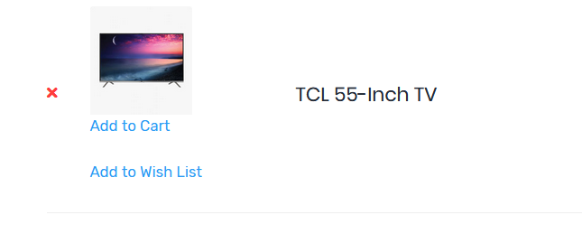

b) Should have a Wish List page listing previously added products

http://localhost:4200/wish-list

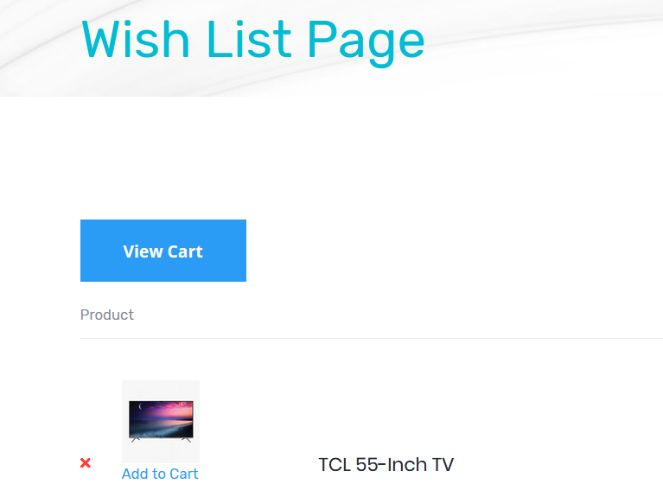

c) Should be able to delete items from Wish List

d) Should be able to “Add to Cart” an item in this Wish List page

2] Recent Reviews at Top Right

a) Should have a Recent Reviews area that opens after clicking an icon in the top right

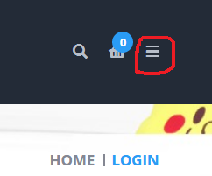

b) Should display recent reviews in this area

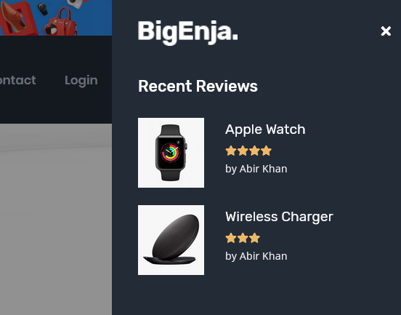

c) Should have product reviewed title, image, rating, etc

